Difei Lu NetID: ldfghh

Jiawei Zhang NetID: jz34

**CSE 415 Assignment4 Report**

We chose option C.2+. The 2 common puzzles we picked are sudoku and Pentominos.

They are sudoku.py and Pentominoes.py respectively.

**Report for sudoku:**

Puzzle 1:

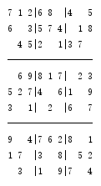

|  |  |  |  |
| --- | --- | --- | --- |
|  | Solved? | Path length | Total states |
| Heuristic 1 | Yes | 24 | 25 |
| Heuristic 2 | Yes | 24 | 25 |
| No heuristic | Yes | 24 | 25 |

Puzzle 2:

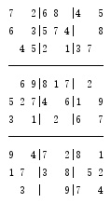

Puzzle 2 is harder than puzzle one. The first heuristic is still able to solve it with path length of 29 and total state of 30. But heuristic 2 and uniform cost search are taking much longer, or I would say un able to solve it.

From the result above. I believe that the first heuristic is the best among these three.

**Report for Pentomimes:**

The 6 x 10 Pentomimes puzzles are too time-consuming if I start with a blank puzzle. To save time, I give a initial states with some polygons filled to start the puzzle. In puzzle 1, 8 polygons were placed. In puzzle 2, 7 polygons were placed.

Puzzle 1:

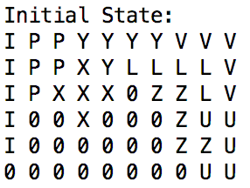 with available polygons F T W N

Solution:

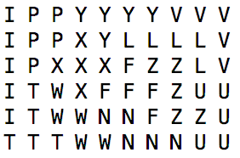

|  |  |  |  |
| --- | --- | --- | --- |
|  | Algorithm | Path length | Total states |
| Heuristic 1 | A* | 4 | 114 |
| Heuristic 2 | A* | 4 | 818 |
| No heuristic (h=0) | A* | 4 | 837 |
|  | BFS | 4 | 837 |

Puzzle 2:

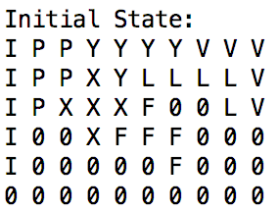with available polygons T W N U Z

Solution:

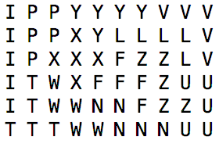

|  |  |  |  |
| --- | --- | --- | --- |
|  | Algorithm | Path length | Total states |
| Heuristic 1 | A* | 5 | 521 |
| Heuristic 2 | A* | 5 | 2234 |
| No heuristic (h=0) | A* | 5 | 2234 |
|  | BFS | 5 | 2234 |

From the results shown above, the heuristic 1 works better which is hamming heuristic function, and heuristic 2 seems useless in puzzle 2.

Retrospective  
Difei: During this assignment, I mainly focused on the sudoku problem and I finished all of it. From This assignment, I start to understand the importance of heuristics. It is the key to solve any problem. We should fully understand the problem so we can come up with efficient heuristic.

Jiawei: During this assignment, I mainly focused on the Pentominoes problem and I finished all of it. From this assignment, I learnt how to use 2D array in Python and I have a better understanding on heuristics function that the heuristic values will give a better performance if the value is close to the actual h. We debugged each other’s codes together. I benefitted from this collaboration a lot.